BUILDING BETTER FUTURES THROUG ICT AND AGRICULTURE FOR URBAN YOUTH IN LIBERIA
POLICY BRIEF
ACTIONAID LIBERIA
12/15/2017

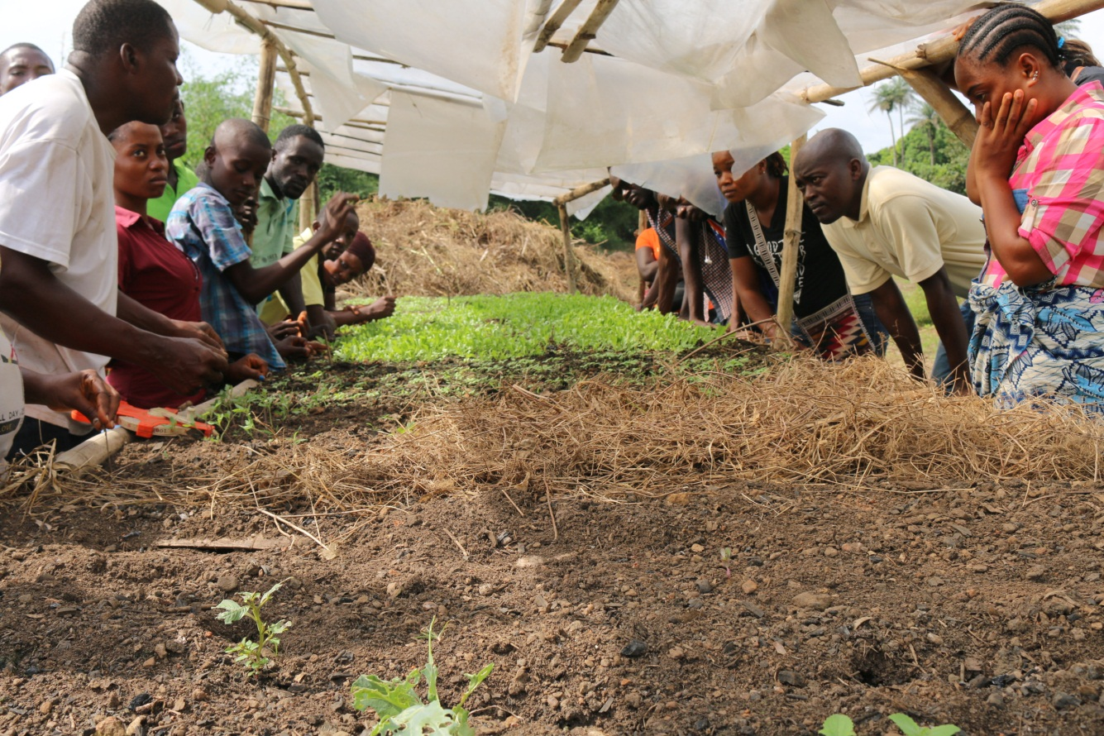

Contents
YOUTH ICT AND AGRICULTURE POLICY BRIEF 1
INTRODUCTION 1
THE POLICY BRIEF 2
EVIDENCE AND ANALYSIS 3
PROLICY IMPLICATIONS AND RECOMMENDATIONS 4

YOUTH ICT AND AGRICULTURE POLICY BRIEF

INTRODUCTION

Youth ICT and Agriculture is a project funded by Turing Foundation through ActionAid Netherlands. Its main object is to contribute to the reduction of youth unemployment through the creation of ICT based youth-driven agriculture social enterprises. The specific objective is to;

- Create a youth led ICT based agriculture value chain.

Building better futures through ICT and Agriculture for urban youth in Liberia; looks at the role of young people using social enterprise in agriculture for sustainable livelihoods. It seeks to advocate for more support of youth social enterprises from the government; Engage 10 accountability forum members in urban farming using the organic fertilizer they manufacture from recycled waste and establish 5 social enterprises are working cooperatively to produce and sell value added agriculture products to generate income.

Within this context, Building better futures through ICT and Agriculture for urban youth in Liberia project has done a survey on the challenges faced by young people of Liberia to be able to grow ICT and agricultural activities across the country. The research makes clear that across Liberia, there is a need for young people to engage into community led Agri – Food cultural and ICT led food production initiatives. These initiatives seek to create self-sustainable employment for young people therefore alleviating poverty food production that have been threatened by the rise of convenience, imported foods and fast foods production. Such projects have potential to revive endangered practices of food production, and at a community level, can contribute to the transmission of knowledge and skills about foo, the organic and preservation of food heritage and improved understanding and tolerance between different socio-economic groups. Yet their ability to flourish is often challenged by:

- Competing pressures on urban space, which mean that community groups often have only precarious access to land for growing
- Lack of support for existing young upcoming farmers
- Societal trends, which encourage consumption of food that is fast, cheap and unhealthy;
- Threats to biodiversity, especially the loss of seed varieties which undermine the very fabric of locally distinctive food cultures.

THE POLICY BRIEF

The goal of this policy brief is to highlight the importance of youth led Agricultural and food initiatives through ICT, the changing spaces of production, marketing and consumption. It provides some brief challenges that young people are faced with and makes recommendations for policies which are needed to enable these to thrive.

EVIDENCE AND ANALYSIS

Liberia has a huge youth bulge but deprivation of basic and essential services, opportunities and livelihood options pose significant threat to youth development and economic progress in the country. Liberia’s current population is 4.4 million with approximately 63% under 25 years old. About 47% of this population lives in urban areas. ‘Urban’ in this context includes communities with 1500 or more participants; many who still lack adequate access to basic services. Montserrado County, where the capital Monrovia is located, is the most densely populated county in Liberia. Over 1 million people live in and around the capital and more than ¾ of Monrovia’s population is under 35 years old. Less than 70% of Liberia’s youth have access to secondary or tertiary education, or formal job training and the quality of life is poor; education, health, and economic opportunities, and protection are low.

Liberia’s economy consists of agriculture (52% GDP), forestry (12% GDP) and concession reliant industrial sectors (12% GDP). Small household and subsistence farming make up the majority of farming in the agricultural sector with 41% of all households in Liberia dependent on food crop production for their livelihoods. Although rice is a staple food for Liberian, rice is also one of the primary imports. Rural poverty is endemic and nearly 68% of the rural population lives below the national poverty line, thus prompting rural to urban migration mainly by youth. This has exacerbated existing pressure on infrastructure (potable water, sanitation, sewage and garbage disposal, electric supply, roads, as well as education and health services) and resulting in poverty no longer being a predominantly rural phenomenon.

In 2014, Liberia became the epicenter of the Ebola Virus Disease (EVD) crisis, with an estimated 4,000 deaths since March 2014. EVD outbreak also shook the fabric of social life, tearing families apart and taking the lives of bread winners. Trade was cut off, Borders closed and limited numbers of ships were operating. The importation of goods declined leading to significant price increase on commodities including rice and other basic staples. The economic impact of the Ebola outbreak on border trade, food production, reduction in labor force, contributed to lack of food security, unemployment and income generation, these were even more critical. For many families struggling with poverty, the consequences were worsened.

To this date most of young people are; uneducated; unskilled; unemployed; without resources; and frustrated. EVD outbreak exacerbated the need for critical engagement and support to build communities’ resilience for prevention of conflicts and disaster preparedness.

Working with youth for the realization of their economic and social rights is therefore both an issue of justice as well as a cautionary measure to ensure achievement of conflict free Liberia.

PROLICY IMPLICATIONS AND RECOMMENDATIONS

Youth led Agricultural and Food initiatives can offer many lessons for government structures and professionals seeking a more active engagement of citizens with cultural resources. These initiatives can be regarded as experimental spaces in which the participants engage in the co-construction of shared Agri - cultures. This involves experiential learning and capacity building processes of the use of ICT to market, communicate and get peer to peer technical advice, ‘reflexive governance, to promote social inclusion. The projects combine ‘hands on’ practical engagement with growing , and the use of social media and digital technology to communicate and build communities around agricultural initiatives.

There are many opportunities to link agricultural and food culture with the arts and creative sectors such as through festivals of film, performance arts, and crafts. Agri and Food culture in this way can become a basis of the construction of culture economies which can deliver local, regional and national development. An example is Slow tourism, which links Agri and food culture with leisure, in the framework of a re-prioritising the ‘experience’ of travel over the ‘acquisition’ of destinations.

In terms of policies, Agriculture and food is cross-cutting, so policy makers need to be aware of how different funding sources, policies and strategies could be combined within the framework of territorial or ‘place-based’ development. For example, intensive agricultural development can have a profound effect on historical irrigation systems of high cultural value:

- Liberia’s Land rights policy that is still pending infront of the house of Senate allows young people regardless of sex to have access to land so they are able to produce sufficient food for the country and beyond.
- The Land rights should be able to has a renewed emphasis on supporting community-led local development.
- Liberia’s Agricultural policy should be able to cater and support young aspiring agriculturists
- Liberia should be able to put an Agricultural Development Fund in place, to assist young Agri and Food culturists’ gain skills and knowledge in economic production based crops and food. This fund shall finance Youth-led development projects that promote Agri and Food cultural.
- Liberia’s food quality policy protects food products with quality attributable to place of origin, through the Protected Designation of Origin and Protected Geographical Indications schemes. These can help to protect foods that draw on distinct local farming and food cultures.
- Liberia’s cultural heritage resolution “Towards an Integrated Approach to Cultural Heritage for Liberia stresses the importance of gastronomic heritage, which must be protected and supported. It also considers that the resources allocated to this area can be optimised through interaction with other Liberia policies, such as the common agricultural policy and consumer protection policy.

RECOMMENDATIONS
This policy brief recommends that the ‘bottom-up’ development of ICT and Agricultural and Food projects should be nurtured through policy tools to support it and by removing the barriers to growth. The key is to enable young people to develop their projects, rather than attempt to regulate or standardise such efforts. The aim should be to develop a diverse ecosystem of youth Agriculture and food initiatives, by providing the right conditions. Therefore this policy brief recommends:

- Protecting communal spaces for growing, preparing and sharing food.
- Supporting initiatives which enable young people to do experiential learning “learn by doing” such as, for example, helping out on farms, taking part in cookery exchanges, being involved in the restoration of food heritage sites such as walled gardens, community orchards, city and rural farms and so on.
- Ensuring that young Agri- Food culturists have access to land so that they can try out their innovations and build new business models.
- Supporting young farmers with adequate equipment and orienting them on such machinery.
- Making sure that rural areas have high quality broadband connections: digital technology and smart media are vital to enable sharing of ideas and building a sense of community.
- Recognizing and valuing the direct and indirect benefits of community young people growing initiatives, which according to the discussion research included: improvements in health and wellbeing; contribution to social cohesion; maintaining, restoring and improving urban environments (including built heritage and green spaces); enhancing urban biodiversity; supporting rural economies in the Agri-Food culture, tourism and craft sectors.
- Recognizing that seeds are part of Liberia’s cultural heritage common property and that their diversity needs to be protected.
- Finding ways to share examples of best practices; undertake more systematic cross-cultural research in order to generate a more accurate picture of the full scale of community food activities across the Liberia and to help facilitate the exchange of ideas and learning.

